CITY OF SELMA
JOB POSTING

POSITION: (2) Prosecutor

DEPARTMENT: Municipal Court

LOCATION: City of Selma Court house

STATUS/SCHEDULE: Part-time $ 500 a month for each

OPENING DATE: February 9, 2022 CLOSING DATE: March 9,2022
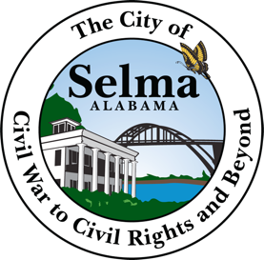

Job Summary
We are looking for a passionate prosecutor to represent victims in criminal court cases. The responsibilities of prosecutors include interviewing witnesses, reading through police reports, and performing legal research to plan the prosecution of each case.

To be successful as a prosecutor, you should demonstrate good reasoning skills, an understanding of the community's needs, and excellent public speaking abilities. Ultimately, a top-notch prosecutor should be comfortable in the courtroom, possess effective communication skills, and superior research skills.

Prosecutor Responsibilities:
- Working with police officers and court staff.
- Instructing and advising counsel in court.
- Liaising with criminal justice and law enforcement agencies.
- Ensuring that criminals are punished fairly.
- Screening possible criminals.
- Handling appeals.
- Preparing criminal cases for pre-trial and trial.

Prosecutor Requirements:
- Law degree from an accredited law school.
- Must be a member of the Bar Association.
- Strong written and oral communication.
- Good reasoning and logical skills.

APPLICATIONS INCLUDING YOUR RESUME SHOULD BE SUBMITTED TO THE PERSONNEL DEPARTMENT 222 BROAD STREET SELMA AL 36701

THE CITY OF SELMA IS AN EQUAL OPPORTUNITY EMPLOYER

