CITY OF SELMA
JOB POSTING

POSITION: (2) Public Defender

DEPARTMENT: Municipal Court

LOCATION: City of Selma Court house

STATUS/SCHEDULE: Part-time $ 500 a month for each

OPENING DATE: February 9, 2022 CLOSING DATE: March 9,2022
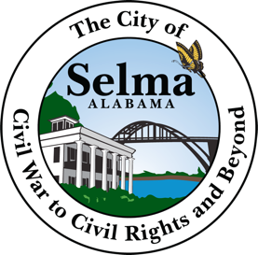

Job Summary
We are looking for a competent public defender to handle all duties involved in managing indigent defendants' court cases. The public defender's responsibilities include providing clients with legal representation during all phases of a case, preparing and presenting their defense, and ensuring the timely submission of legal documents and reports.

To be successful as a public defender you should be able to perform legal research, analyze and apply legal principles. An outstanding public defender should be able to defend criminal cases successfully and maintain cooperative working relationships with all stakeholders.
Public Defender Responsibilities:
- Providing legal representation, consultation, and advice to clients.
- Representing clients during criminal investigative proceedings.
- Preparing a defense, conducting legal research, gathering facts, and interviewing the client and witnesses.
- Working closely with clients, providing and discussing information, strategies, and developments.
- Arranging for bail to be set and bonds to be posted.
- Writing motions, pleadings, and legal arguments.
- Preparing legal documentation and representing clients in court.
- Handling pretrial discovery, withdraw pleas, suppression motions, and appeals.
- Attending sentencing and negotiating plea bargains.

Public Defender Requirements:
- Juris doctorate or bachelor of laws degree required.
- Licensed to practice law in the relevant state.
- Previous trial and criminal law experience preferred.
- Knowledge of criminal law, the judicial system, court practices, and procedures.
- Excellent organizational, oral presentation, and communication skills.
- Able to work under pressure with strong attention to detail.
- Strong research, analysis, and decision-making skills.
- Good interpersonal and diplomacy skills.
- Strong computer skills.

APPLICATIONS INCLUDING YOUR RESUME SHOULD BE SUBMITTED TO THE PERSONNEL DEPARTMENT 222 BROAD STREET SELMA AL 36701

THE CITY OF SELMA IS AN EQUAL OPPORTUNITY EMPLOYER

