CITY OF SELMA
JOB POSTING

POSITION: Custodian

DEPARTMENT: Public Buildings

LOCATION: City Hall

STATUS/SCHEDULE: Regular, Part –Time/ Full Time

OPENING DATE: May 3rd 2021 CLOSING DATE: Until Filled
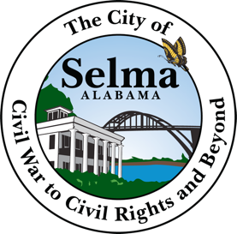

Job Summary
Under supervision of the director, maintains upkeep and appearance of City Hall, will perform daily cleaning duties such as dust furniture, and equipment, wash windows, walls and wood work, vacuum, sweep and mop floors, cleaning restrooms and offices, remove cobwebs, despoils of refuse and trash. Replenish cleaning products as needed. Reports damaged and or broken items or objects. Performs other related tasks concerning the up keep of City Hall

Credentials and Experience
High school diploma or GED

Working hours:
** This position involves working 10hours per week. Will be required to work flexible hours including evenings and weekends as needed. Will be required to rotate to other public buildings. **

Applications are available in the personnel Department at City Hall located at 222 Broad Street, Selma, AL 36701 Office hours are Monday –Friday from 8:30 a.m. to 4:30 p.m.

