CITY OF SELMA
JOB POSTING

POSITION: School Guard FLSA Status: Non-Exempt

DEPARTMENT: Police

LOCATION: Police Department

STATUS/SCHEDULE: Regular, Full-time

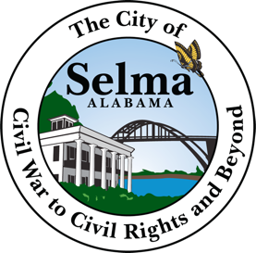
OPENING DATE: February 7, 2022 CLOSING DATE: February 21, 2022

JOB SUMMARY
Under the directions of the Police Department the employee is responsible for ensuring the safety of children and drivers in school zones. Sets up school zones to warn drivers of pedestrians. Directs traffic and school children crossing the street. Works with other guards to monitor illegal parking in downtown. Assist with traffic and car problems.

DUTIES AND RESPONSIBILITIES
A. School Crossing (%) – Sets up school zone signs in morning before school starts to warn drivers of pedestrians. Directs traffic and school children using hand signals and whistle. Removes school zone signs after school has started and waits after school starts to help late students across street. Sets up school zone signs in afternoon before school ends to warn drivers of pedestrians. Controls traffic flow of cars picking up students and cars on the road using hand signals. Assist students across the street, ensuring traffic has stopped before signaling them across. Removes school zone signs after traffic flow from cars picking up students has slowed down. Stays until all students have been picked up or have walked home.

B. Parking Meter Monitoring and Traffic Assistance (%) – Works with other school guards to monitor meter parking downtown. Marks tires of cars parked at meters with chalk and ticket any cars on meters that are expired. Checks every two hours to ensure cars have not exceeded their time limit or violating a parking ordinance. Assists with any traffic or car problem.

C. Miscellaneous (%) – Performs other duties as required.

Knowledge, Skills and Abilities – Knowledge of city traffic and parking laws. Knowledge of traffic flow control procedures. Ability to learn, understand, interpret and enforce appropriate related city and state parking and vehicle codes, laws and regulations. Ability to identify and report parking and traffic problems encountered in the course of work. Ability to effectively communicate orally.

Credentials and Experience – Any experience that would provide the listed qualifications will be considered.

APPLICATIONS INCLUDING YOUR RESUME SHOULD BE SUBMITTED TO THE PERSONNEL DEPARTMENT 222 BROAD STREET SELMA AL 36701

THE CITY OF SELMA IS AN EQUAL OPPORTUNITY EMPLOYER

