CITY OF SELMA
JOB POSTING

POSITION: Sales Clerk

DEPARTMENT: Planning and Development

LOCATION: Welcome Center

STATUS/SCHEDULE: Part-time

OPENING DATE: February 7, 2022 CLOSING DATE: February 21, 2022
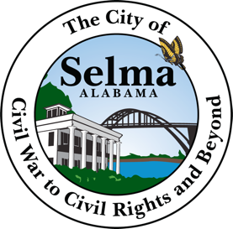

Job Summary
We are looking for an energetic and customer service-oriented sales clerk to work in our store. The sales clerk is responsible for packing shelves, ringing up items for customers and keeping track of inventory.

Sales Clerk Responsibilities
- Greet customers
- Answer customers’ questions
- Locate items for customers
- Monitor inventory
- Ring up items for customers
- Elevate feedback from customers to management
- Maintain and balance cash drawer daily with extreme accuracy and secure the money on a daily basis.

Sales Clerk Requirements
- Excellent customer service skills
- Ability to remain calm with difficult customers
- Knowledge of cash management procedures and best practices
- Cash counting skills
- Prior experience in retail
- Ability to work in a team
- Flexible work hours
- Have a high school education or equivalent training experience

THE CITY OF SELMA IS AN EQUAL OPPORTUNITY EMPLOYEE

Applications are available in the personnel Department at City Hall located at 222 Broad Street, Selma, AL 36701 Office hours are Monday –Friday from 8:30 a.m. to 4:30 p.m.

