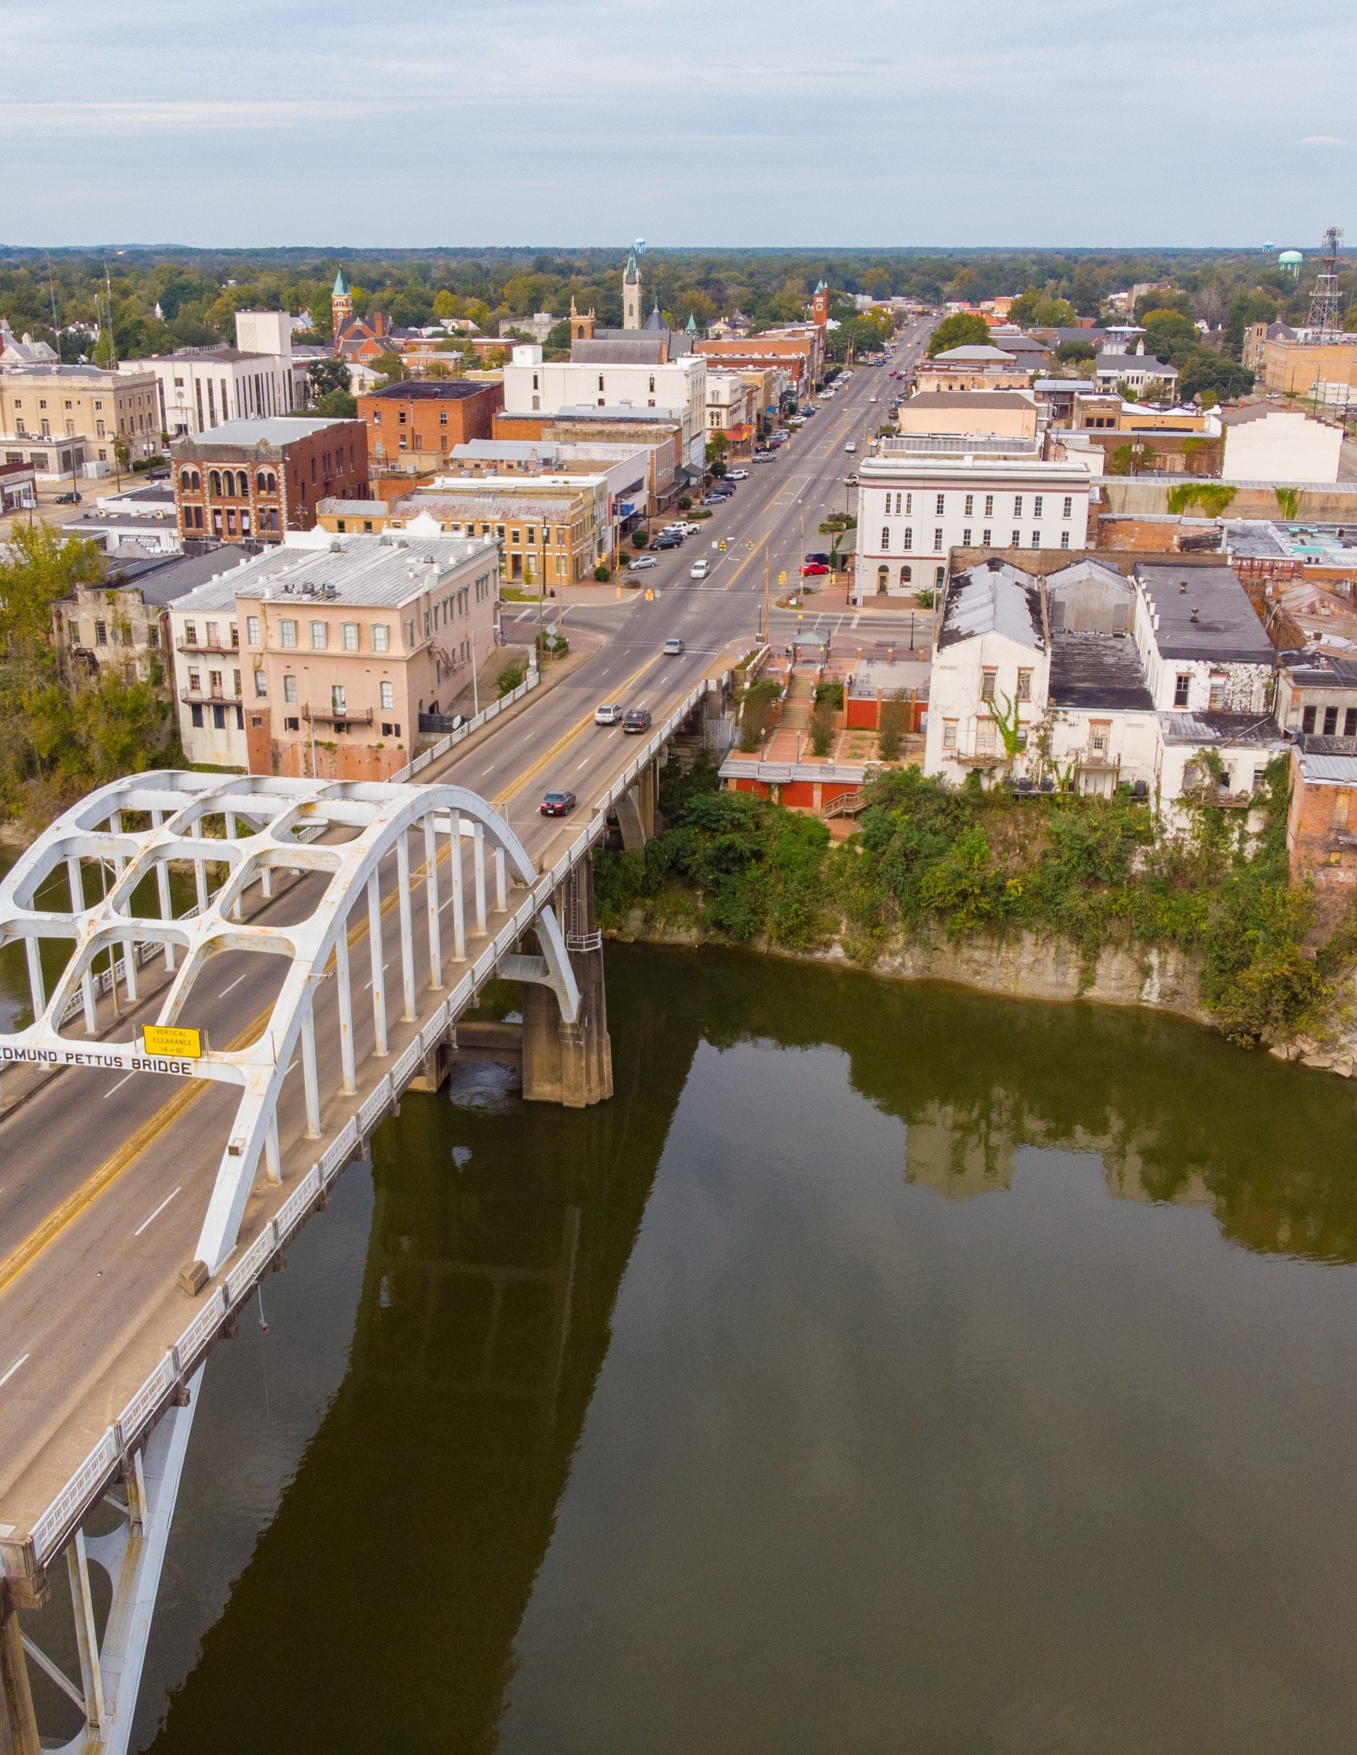
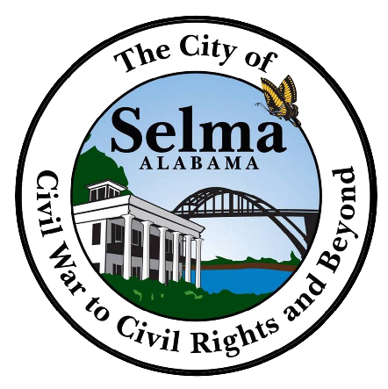
selma-al.gov

CITY SEAL

CITY OF SELMA
REQUEST FOR PROPOSALS
For AmeriCorps Consultant

RFP# PD-23-0001
RELEASED ON March 23, 2023

OFFICE OF PLANNING & DEVELOPMENT
DANIELLE WOOTEN, DIRECTOR
Email: dwooten@selma-al.gov
Phone: (334) 874-2111

2 2 2 B R O A D S T R E E T | S E L M A, A L A B A M A 3 6 7 0 2

SCHEDULE OF EVENTS:

This Request for Proposal shall be governed by the following schedule:

Release of RFP
Deadline for Written Questions Proposals Are Due
Proposal Opening Approval of Contract

March 27, 2023
March 31, 2023
April 3, 2023
April 4, 2023
April 11, 2023

Location for all events:

City of Selma 222 Broad Street
Selma, AL 36701

4:30 PM
4:30 PM City Clerk's Office 9:30 AM Council Chambers 6:00 PM Council Chambers

**All dates are subject to change at the discretion of the City.

2

INTRODUCTION
The City of Selma ("City") invites qualified candidates to submit proposals for
contractual consultant services. The City is seeking to contract with an individual or firm
that specializes in consulting services as it relates to AmeriCorps services for
housing program and workforce planning.

BACKGROUND
The Office of Planning & Development is responsible for long-range planning for the City of
Selma, as well as the day-to-day administration of various City, State and Federally funded
programs geared toward the physical and economic renewal of the City. It is the intent of the
City to apply for grants which address documented City needs associated with service delivery
and necessary capital infrastructure improvements that can be properly and efficiently administered
by staff taking into account existing duties and responsibilities. The goal of the City’s grant program
is to secure funding for services and projects which the City otherwise would be required to utilize
local tax dollars.

PROPOSAL SUBMISSION CONDITIONS AND INFORMATION
Proposals must be received by the City of Selma by 4:30 PM on April 3, 2023.
Late proposals will not be considered. The City highly encourages early submission of
proposals. The City reserves the right to amend or supplement this RFP prior to the Proposal
due date. All addendum(s), responses to questions received, and additional information
will be electronically posted at www.selma-al.gov and/or www.facebook.com/selmacityhall.

Proposer shall submit one certified hard copy and one electronic copy of the proposal including any supporting documentation addressed as follows:

City Clerk - 222 Broad Street Selma, AL 36701
Email: purchasing@selma-al.gov and planningdevelopment@selma-al.gov

The subject line must clearly state:
Proposal Attached – RFP for AmeriCorps Consultant Services

From the date that this RFP is issued until the selection is announced, Proposers are not allowed to communicate outside the process set forth in this RFP with any City employee other those listed herein regarding this RFP. The City reserves the right to reject any Proposal for violation of this provision.

The selected Proposer will execute a Professional Service Agreement with the City describing the Scope of Services to be performed, the schedule for completion, compensation, and other pertinent provisions. The contract shall follow the sample form of Agreement provided as Appendix B to this RFP, which may be modified by the City. Submittal of a Proposal shall be deemed acceptance of all the terms set forth in this RFP and the sample agreement for services unless the Proposer includes with its Proposal, in writing, any conditions or exceptions requested by the Proposer to the proposed Agreement.

SCOPE OF WORK
A professional consultant will be used to facilitate project planning and provide training and technical assistance to implement an effective AmeriCorps program with evidence-based strategies. The city has engaged planning professionals to conduct current and previous comprehensive plans where community feedback and planning meetings are coordinated to assess and analyze community needs that can be addressed through a refocused AmeriCorps program and implementation plan.

Consultants will design a programmatic framework, needs assessment, implementation and training plan, and financial budget, policies, procedures, and processes with evidence-based strategies to included but not limited to the following components:

AmeriCorps Workforce Development & Housing Rehabilitation framework that enables participation of members in workforce development programs to build knowledge, skills, and abilities in industry standards and practices for hands-on application and placement as well as turnaround training opportunities to community members to improve capacity to repair and rehabilitate dilapidated units into quality housing.
Home Ownership & Job Readiness framework for training opportunities to learn and share resources that enhance knowledge of financial literacy, lending, saving, investing, and budgeting along with soft skills.
Sustainable Living & Community Development framework community outreach and partnerships efforts to promote self sufficiency and the importance of positive community mindsets and activities such as neighborhood clean ups, networks, and events.

SERVICES REQUIRED:
- Facilitate project planning and provide training and technical assistance aimed at improving the applicant's ability to implement an AmeriCorps program effectively.
- Assess and analyze community needs-related information to identify specific gaps or needs that can be addressed through AmeriCorps.
- Research appropriate evidence-based interventions to inform service activities to be performed by AmeriCorps members.
- Develop a program theory of change, logic model, needs assessment, implementation and training plan, and financial budget, policies, procedures, and processes
- Outreach and establishment of community partnerships to support the planning and implementation of an AmeriCorps program, and partnership planning meetings.
- Develop plans for member recruitment, selection, placement, training, and supervision.
- Develop plans and systems for ensuring grant compliance and accountability.
- Develop internal controls and specific programmatic and financial policies and procedures.
- Travel to training and technical assistance sessions with Commission staff.
- Travel to see and learn about program models the applicant is interested in replicating.
- Training new staff or refocusing and training existing staff in the areas of AmeriCorps Member Recruitment, Enrollment, Data Collection Systems, Member Supervision, or Cost Reimbursement Grant management, etc.

.

PROPOSAL REQUIREMENTS
Proposers must submit a detailed proposal which includes, at a minimum:

- Project Approach - Describe the procedure and plan for the proposed project
plan should include an outline of milestones and timelines.

- Qualifications/ Experience - Describe the background, experience and qualifications
of the person(s) who will act as the AmeriCorps Consultant and the qualifications of any staff who will assist (include their role, education, relevant experience and related qualifications)

- Professional References - Provide at least three (3) references including the name of contact, affiliation, address, direct telephone number and email address.

- Cost Proposal - Describe in detail the fee structure you propose for providing services. Fee schedule should be all-inclusive and detail the price breakdown including all fees.

EVALUATION & SELECTION
The city will make its selection based on its review of the proposals submitted. Proposals will be evaluated based on written materials as outlined herein and rated according to the rating system as follows:

Rated Criteria Category | Weighting (Points)
1. Qualifications and experience | 30
2. Project approach and work plan | 30
3. Cost Proposal | 20
4. Ability to meet the needs of the City | 20
Total Points | 100

The City of Selma reserves the right to reject any or all the proposals, to waive informalities in the proposals, or the proposal process. The City may interview selected proposer. In addition to conducting an oral interview, the City may also contact and evaluate the Proposer’s references, contact any Proposer to clarify any response or request revised or additional information, contact any current users of a Proposer’s services, solicit information from any available source concerning any aspect of a Proposal, and seek and review any other information deemed pertinent to the evaluation process.

During the evaluation process the City may make a recommendation for award, or
it may request Best and Final Offers from Proposers. The City may accept the
Proposal or negotiate the terms and conditions of the agreement with the highest ranked firm, which shall be determined to be the lowest responsible bidder. The City may recommend award without Best and Final Offers, so Proposers should include
their best Proposal with their initial submission. Recommendation for award is contingent upon the successful negotiation of final contract terms. Negotiations shall be confidential and not subject to disclosure to competing Proposers unless an agreement is reached. If contract negotiations cannot be concluded successfully within a time period determined by the City, the City may terminate negotiations and commence negotiations with the next highest scoring Proposer or withdraw the RFP.

INSURANCE REQUIREMENTS
All vendors, companies and individuals shall procure and maintain during the term of the contract the following insurance policies:
- General Liability
- Automobile Liability
- Workers Compensation & Employers Liability
- Professional Liability and Errors and Omissions

AWARD
The City of Selma reserves the right to award the contract to other than the lowest proposer if such action is deemed to be in the best interest of the City in accordance with the evaluation criteria. Upon selection, the City of Selma will mutually discuss and refine the scope of work with the successful Proposer and shall negotiate final conditions, compensation, and performance schedule for contract approval by the Selma City Council on April 11, 2023.

RFP QUESTIONS AND RESPONSES
Questions regarding this proposal must be submitted in writing by March 31, 2023.
No other than written questions will be accepted, and no other than written responses will
be binding. Please submit all written questions to:

Danielle Wooten, Director
The Office of Planning and Development
Email: dwooten@selma-al.gov

STATEMENT OF NON-COMMITMENT
Issuance of this RFP does not obligate the City of Selma to award a contract or to pay any costs incurred in preparation of proposals responding to this RFP.

selma-al.gov

